Spanish Octopus terrine 22  charmoula, shishito peppers & rye crumble  Wood Charred Shishito Peppers 12  miso yogurt & sesame seeds (gf )  Tuna Crudo* 16  sunchoke crème, yuzu-ginger vinaigrette,  cucumber & breakfast radish  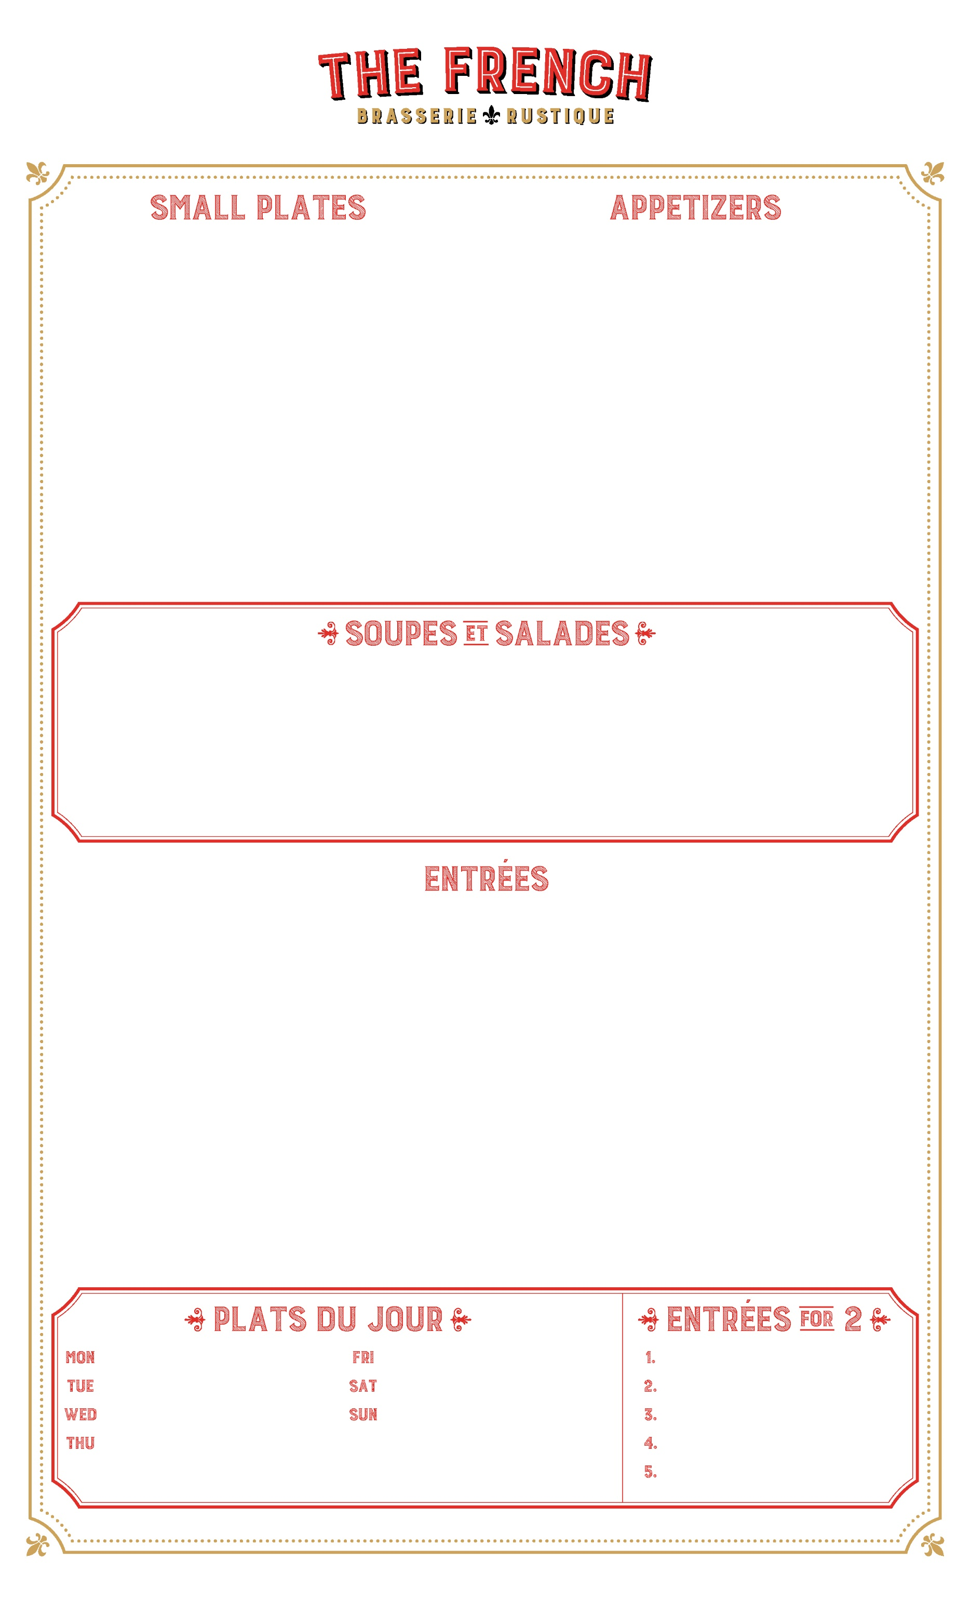  Caramelized brussel sprouts 14  agrodolce, bacon lardon  Deviled Eggs “Mimosa” 14  american caviar, dijon mustard & espelette pepper  Escargot 15  burgundy snails, parsley butter, garlic &  house-made puff pastry | Fried Squash Blossoms 18  housemade milk ricotta, tomato & basil  Burrata Tortelli 25  lobster, fava beans, corn & crustacean glaze  Beef Tartare* 18  hand cut beef eye round, cornichons, egg yolk  & market greens  Foie Gras Torchon 23  meyer lemon jam, brioche & sea salt  Oysters of the Day* 6/$18 or  assortment of east & west coast 12/$29  Steamed Mussels “Marinieres” 18  shallots, garlic, white wine, parsley & chives

Baked Onion Soup 12  caramelized onions, ementhal cheese,  toasted baguette & rich beef broth  Salt Roasted Beet Salad (gf ) 16  crumbled french feta, lentils du puy  toasted pistachio and charmoula  Kale & Chickpea Salad (gf ) 15  tahini, lemon, pecorino cheese & winter pears | Lobster Bisque 15  lobster claws & crème fraiche  Warm Goat Cheese Salad (gf ) 14  locally grown lettuces, bacon lardon, chive &  caramelized goat cheese  Roasted Butternut Squash Soup (gf ) 12  spiced crème fraiche & toasted squash seeds

Wood Grilled Riviera Swordfish 34  puffed farro, french feta cheese, cucumbers,  nicoise olives, tomato & lemon yogurt  All Natural Roasted Chicken Breast 28  sunchoke crème, chanterelle mushrooms  fingerling potatoes & comte cheese  Mediterranean Branzino 42  french bean ragout, escarole, fennel & coriander  Le Brasserie Burger* or L’Impossible (plant) 24  prime rib burger, applewood bacon gruyere cheese  caramelized onion marmelade & brioche bun **  Heritage Pork Loin Chop * 34  potato-leek “dauphinoise” & honey glazed carrots  Roasted Duck Leg Confit 39  locally grown lacinato kale & apricot mostarda | Black Truffle Risotto 32  creamy arborio rice, brie de meaux & chive  Pan Roasted Black Grouper* 40  artichoke barigoule & potato mousseline  Morrocan Lamb Tagine 32  sundried tomato cous-cous, green harissa  carrots, zucchini, butternut & eggplant  Brasserie Steak Frites* 34  wood grilled hanger steak, brasserie fries  & sauce béarnaise  Roasted Faroe Island Salmon* 30  caramelized cauliflower, cauliflower veloute  brioche crumbs & dill butter  Steak & Lobster “Terre & Mer” * 62  australian angus filet mignon, nova scotia lobster  creamed spinach & bordeaux wine reduction

Coq au Vin 29  Veal Scallopine 34  Trout Amandine 30  Snapper en Papillote 38 | Bouillabaisse 38  Roasted Prime Rib 44  Cassoulet de Toulouse 33 | 3 pound Beef Tomahawk 125  2 ½ pound Whole Snapper 75  Whole Iowa Lamb Rack 92  3 pou. Roasted Poulet Rouge 54  Shortrib Bourguignon 63

Vin Rosé
L’Abbaye Cuvee Benjamin (syrah/grenache) 11
Notorious Pink (grenache) 11
Esprit Gassier Rosé de Provence (grenache) 13
Domaine de Triennes Rose Provence (cinsault) 13

Vin Rouge
Côtes du Rhône, Domaine de Couron 13
Syrah/Grenache, Château Puech-Haut 15
Merlot/Cabernet, Chât. Chastelet (Bordeaux) 13
Cab Sauvignon, Chât. Haut Nouchet (Bordeaux) 19
Pinot Noir, Famille Marchand Côte d’Or 16
Malbec, Jean-Luc Baldes Clos Triguedina 13

Mousseux (Bubbles)
Zardetto Prosecco “Zeta” Superiore 12
Pierre Sparr Crémant d’ Alsace Rosé 13
Charles Heidseick Brut NV (house champagne) 19
Ouidinot Rosé Cuvee 19

Vin Blanc
Chablis, Bourgogne Moillard 14
Chardonnay, Maison Champy 13
Sancerre, Domaine Girard “La Gerenne” 15
Sauvignon Blanc, Francois Chidaine 11
Vouvray, J. Moreau & Fils 13
Pinot Grigio, Tiefenbrunner 12

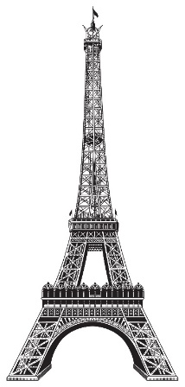
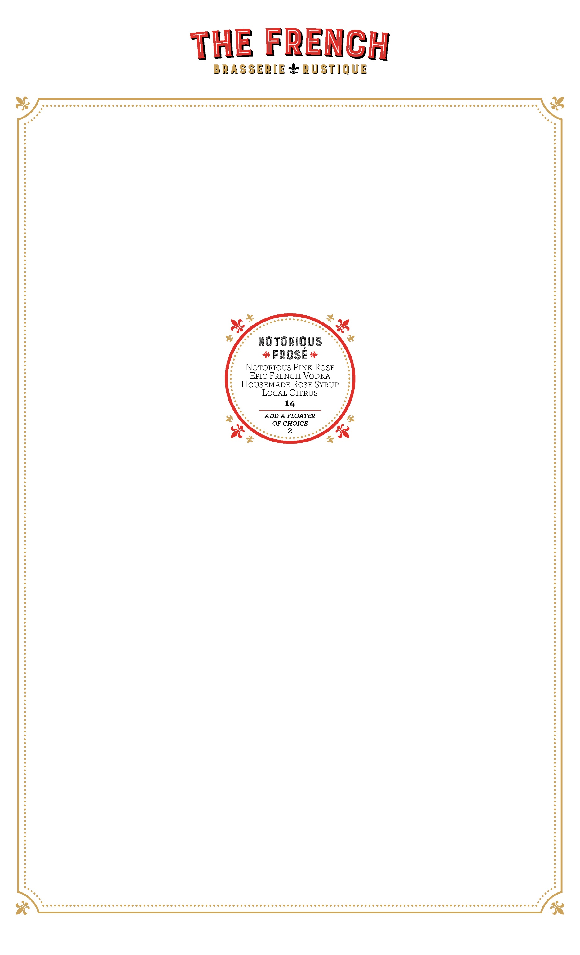
F. Perrin Beaumes Venise Muscat 13
La Fleur d’Or Sauternes 15
Chât. Montifaud Pineau 12
Dom. La Tour Vieille banyuls 13
Chât. de Caladroy Muscat 12
Carmes de Rieussec sauternes 18
Cabral 10yr Port 09
Cabral 20 yr Port 15

Daily Cheese Plate (3pcs) 20

Bottled Beer
Kronenbourg 1664 blanc 07
Stella Artois 07
Ft.Myers Brewing High 5 IPA 08
Lagunitas “lil sumpin sumpin” 07
Le Fin du Monde 11
Chi’Ti Amber (france) 10
La Cadette Blonde (france) 08

On Tap
Kronenbourg 1664 08
Chimay Red 12
Momentum Brewing 16° celsius 08
Ft. Myers Brewing “red tape” 08
Ft. Myers Brewing “fml” Ale 08
Bone Hook Brewing IPA 08
Rotating Tap 08

Absinthe- St.George Verte 14
Grand Marnier 14
Calvados- Pere Magliore 13
Bénédictine - Dom 14
Chartreuse 15
Pastis-Ricard 12
Maurin Quina 13

all desserts 13
The French Eclair, banana jam, praline mousse
Wildflower Honey Crème Brulee
warm Baba Au Rhum, sweetened mascarpone
Baked Alaska, housemade cherry ice cream
chocolate olive cake, raspberry & candied pecans
Gelato by Gelato & Co

*Undercooked fish shellfish, eggs or meat increased the risk of foodborne illnesses. Every effort will be made to accommodate food allergies. Should we be unable to do so, we apologize in advance. *There is risk associated with eating raw oysters. If you have chronic illness of the liver, stomach or blood, or have immune disorders, you are at greater risk of serious illness from raw oysters, and should eat oysters fully cooked. If unsure of your risk, consult a physician. 20% gratuity will be added for parties of five or more.

Vincenzo Betulia, Chef/Owner -Frank Pullara, Chef de Cuisine -Jason Zadorski, General Manager

Rhubarb Bubbley 14
st george gin
strawberry syrup
rhubarb
champagne

autumn tiki 14
old overholt rye
green chartreuse
pineapple-coconut
Nutmeg

Frost Warning 14
Bourbon
Cranberry
Lemon
thyme

vieux carré 14
Whistle Pig rye
ferrand 1840 cognac
carpano antica
bénédictine

hay ride 14
spiced rum
apple cider
cinnamon syrup
lemon

novelle fleur 14
milagro silver tequila
st.germain elderflower
local grapefruit
aperol
la vie en rose 14
epic french vodka
byrrh quinquina
rose petal syrup
peychaud

french 365 14
ford’s gin
hibiscus syrup
cointreau
champagne

scary spice 14
jalapeno tequila
cucumber
grand marnier
chili tincture

