Salade Verte 12  local market greens, fine herbs, shaved radish, fennel, beets & white balsamic vinaigrette  Roasted Carrot Salad 13  lentils du puy, watercress, radish  red wine vinaigrette, lime yogurt  Salt Roasted Beets 15  radicchio, french feta, oranges  almonds & poppy seed vinaigrette  Soupe à l’oignon 09  sweet caramelized onions, baguette  beef broth, emmenthal cheese | Chickpea & Farro 13  lemon tahini, avocado, charmoula  hard cooked egg & cilantro  Escargot 15  burgundy snails, parsley butter, garlic & house made puff pastry  Charcuterie 19  cured french salumi, pâté campagne, pickled vegetables and grain mustard  Tartare de Boeuf* 17  hand cut beef eye round, cornichons  caper, egg yolk, market greens  Lamb Carpaccio 18  grilled eggplant, goat cheese & mint | Fried Squash Blossoms 18  housemade milk ricotta, tomato, basil  Seared Foie Gras* 23  goose liver, red wine poached pears  & french toast  Steamed Mussels 18  vadouvan curry, carrot, celery  shallot & crème fraiche  Deviled Eggs 14  dijon deviled eggs, american caviar espelette pepper & toast  Plateau of Oysters* 18/36  assortment of fresh east and west coast oysters, lemon and mignonette

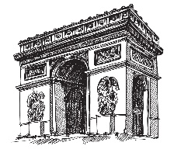
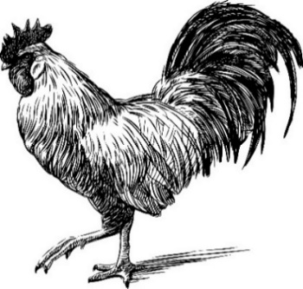

Coq Au Vin 23  red wine braised chicken, bacon lardon  pearl onions, mushrooms and potato puree  Brasserie Steak Frites* 33  grilled hanger steak, maître d’ butter  pommes frites and sauce béarnaise  Beef Shortrib Bourguinonne 48  field mushrooms, carrots, bacon lardon  and red wine jus  All Natural Pork Tenderloin* 29  speck, brussels sprouts, roasted apples  cauliflower creme & calvados glaze  Pan Roasted Chicken Breast 28  all natural chicken breast, forest mushroom ragout  leeks, thyme & garlic confit  The French Brasserie Burger* 23  prime rib burger, applewood bacon, carmelized  onion marmalade, gruyere cheese and brioche bun | Roasted Duck Leg Confit 39  locally grown kale & tart cherry gastrique  Pan Roasted Halibut 39  sautéed swiss chard, garlic, saffron broth  prince edward island mussels  Idaho Trout Amandine 26  green beans, shallots, marcona almonds  brown butter & parsley  Oven Roasted Faroe Salmon* 28  nappa cabbage, buttered leeks salmon roe,  dill & white wine butter sauce  Pan Seared Sea Scallops* 38  sweet potato puree, roasted shiitake mushrooms  and red wine jus  Potato Gnocchi 23  slow braised lamb ragout, aromatic vegetables  parmigiano cheese & oregano

Pommes Frites 08 Creamed Spinach & Comté 12 Brussels Sprouts & Bacon 12

*Undercooked fish shellfish, eggs or meat increased the risk of foodborne illnesses. Every effort will be made to accommodate food allergies. Should we be unable to do so, we apologize in advance. *There is risk associated with eating raw oysters. If you have chronic illness of the liver, stomach or blood, or have immune disorders, you are at greater risk of serious illness from raw oysters and should eat oysters fully cooked. If unsure of your risk, consult a physician. 20% gratuity will be added for parties of six or more.

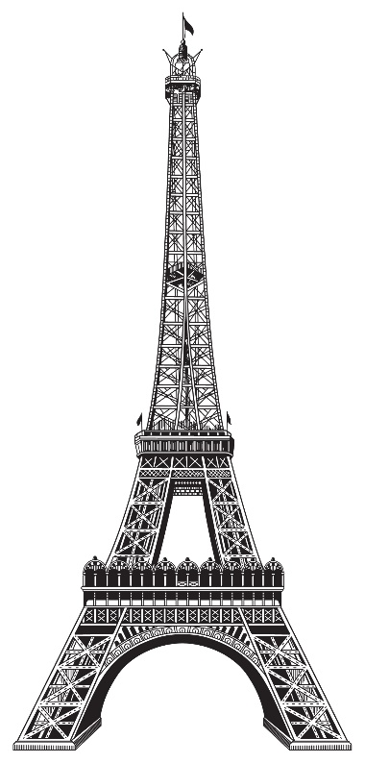
Mousseux (Bubbles)
Helfrich Crémant d’ Alsace 11
Pierre Sparr Crémant d’ Alsace Rosé 12
Charles Heidseick Brut NV (house champagne) 18
Leon Launois Rosé Cuvée 18

Vin Blanc
Chablis, Camille et Laurent Schaller 13
Chardonnay, Macon Fuisse Vincent Girardin 12
Sancerre, Les Glories 14
Sauvignon Blanc, Francois Chidaine 10
Vouvray, Domaine Pichot 12
Pinot Grigio, Tiefenbrunner 10
Vin Rosé
L’Abbaye Cuvée Benjamin (syrah, grenache, cinsault) 10
Notorious Pink (grenache) 10
Esprit Gassier Rosé de Provence (grenache) 12
Domaine de Triennes rosé Provence (cinsault) 12

Vin Rouge
Côtes du Rhône, Domaine de Couron 12
Syrah/Grenache, Château Puech-Haut 14
Merlot/Cabernet, Chât. Chastelet (Bordeaux) 12
Cab Sauvignon, Chât. Haut Nouchet (Bordeaux) 19
Pinot Noir, Domaine Prieuré Côte de Beaune 15
Malbec, Jean-Luc Baldes Clos Triguedina 12

all desserts 12

The French Eclair, banana jam, praline mousse
Baba au Rhum, rhum butter, mascarpone
Vanilla Crème Brûlée, berries, lemon madeline
Jes’s Carrot Cake, rum raisin, coconut gelato

Bittersweet Chocolate Mousse Cake,
berry crème de mure jam

Fromage du Jour (3pcs) 16

vieux carré 13
templeton rye whiskey
ferrand 1840 cognac
carpano antica
bénédictine

french 365 13
ford’s gin
hibiscus syrup
cointreau
champagne

nouvelle fleur 13
milagro silver tequila
st.germain elderflower
local grapefruit
aperol
lillet spritz 13
lillet rose
grapefruit
cremant d’ alsace
rosemary

trocadero 13
makers mark
fernet branca
spiced local honey
walnut bitter

king of anjou 13
grey goose le poire
saint germain
chartreuse
lemon

la vie en rose 13
epic french vodka
byrrh quinquina
rose petal syrup
peychaud

pineapple express 13
pineapple rum
smith & cross rum
fig syrup
lemon

the mariachi 13
milagro reposado
blackberry syrup
gran gala
rosemary tincture

Vincenzo Betulia, Chef/Owner - Frank Pullara, Executive Chef – Jason Zadorski, General Manager

Durban Beaumes Venise Muscat 13
La Fleur d’Or Sauternes 15
Chât. Montifaud Pineau 12
Dom. La Tour Vieille banyuls 13
Chât. de Caladroy Muscat 12
Carmes de Rieussec sauternes 18

Absinthe- St.George Verte 14
Grand Marnier 14
Calvados- Pere Magliore 13
Bénédictine - Dom 14
Chartreuse 15
Pastis-Ricard 12
Maurin Quina 13

Bottled Beer
Kronenbourg 1664 blanc 07
Stella Artois 07
ft. myers brewing high 5 ipa 08
Lagunitas “lil sumpin sumpin” 07
Le Fin du Monde 11
Chi’Ti Blonde (france) 10
La Cadette Blonde (france) 07

On Tap
Kronenbourg 1664 08
Chimay Red 12
Momentum Brewing 16 ° celsius 08
Ft. Myers Brewing red tape 08
Bury Me Creamation Honey Cream Ale 08
Highland Brewing Daycation IPA 08
Rotating Tap 08

